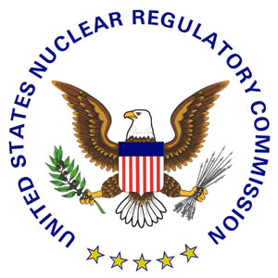 | NRC NEWS  U.S. NUCLEAR REGULATORY COMMISSION  Office of Public Affairs Region IV  612 E. Lamar Blvd., Suite 400  Arlington, TX 76011-4125  Telephone: (817) 860-8128
No. IV-09-023  Contact: Victor Dricks  Phone: (817) 860-8128 | June 19, 2009  E-Mail: opa4@nrc.gov

NRC NAMES NEW RESIDENT INSPECTOR
AT COLUMBIA GENERATING STATION

The U.S. Nuclear Regulatory Commission has assigned Mahdi Hayes as resident inspector at the Columbia Generating Station. The plant, located 10 miles north of Richland, Wash., is operated by Energy Northwest.

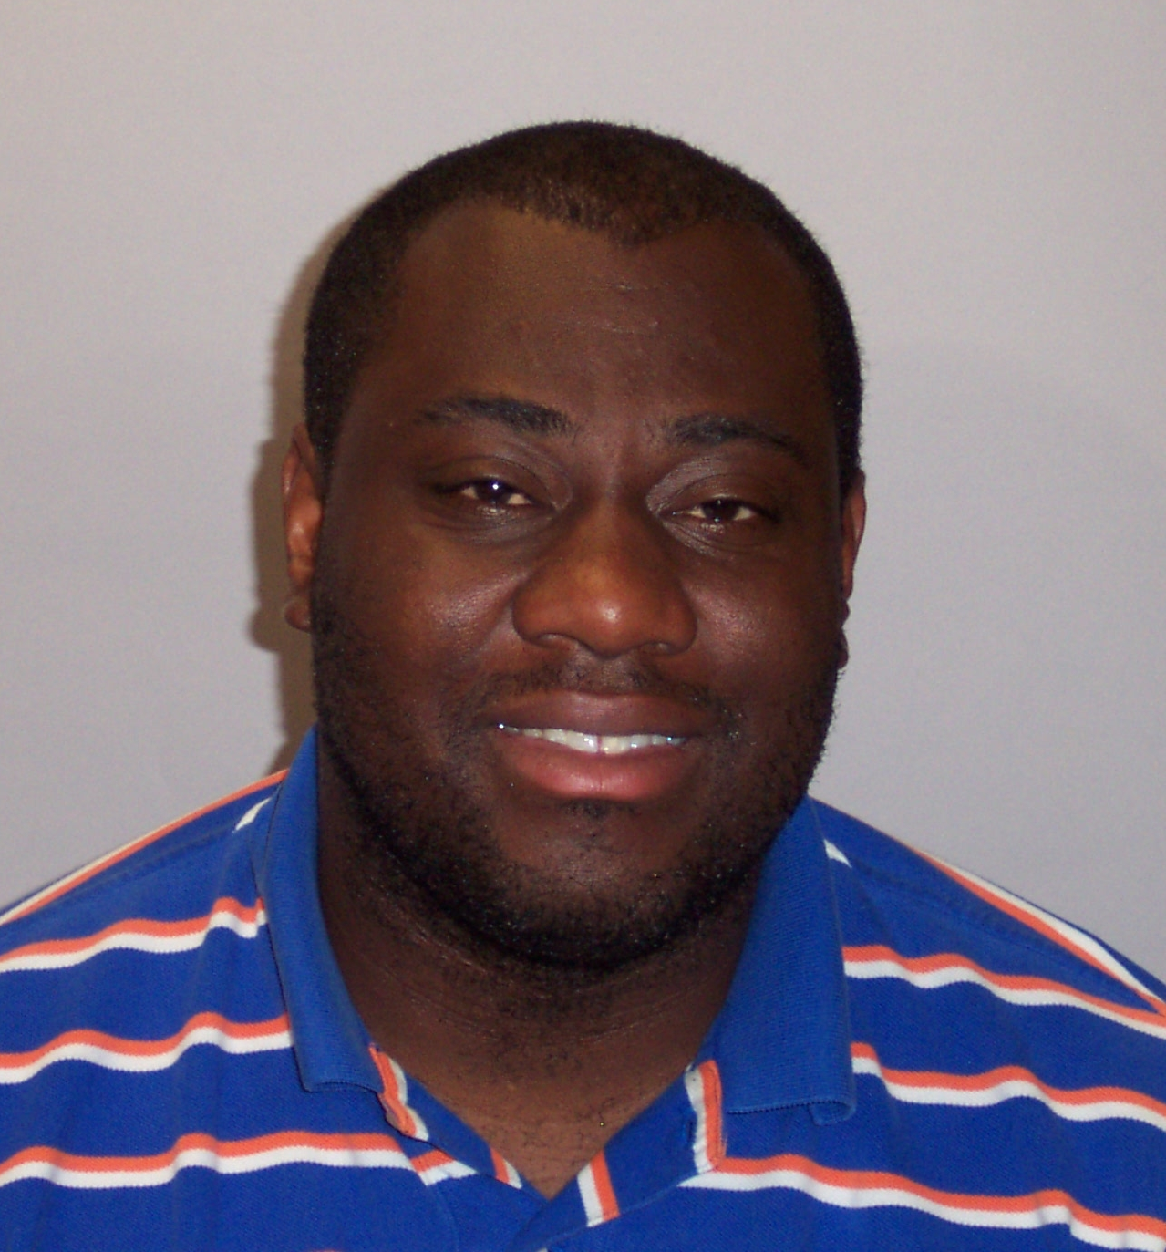
“Mahdi Hayes’ technical and regulatory experience will assist the NRC in carrying out its mission of protecting people and the environment and ensuring the safe operation of nuclear power plants,” said NRC Region IV Administrator Elmo E. Collins.

Hayes joined the NRC’s Region IV office in 2006 as a Reactor Engineer in the agency’s Nuclear Safety Professional Development Program. Prior to joining the agency, he worked as a Nuclear Engineer for Knolls Atomic Power Laboratory. Hayes received his bachelor’s degree in nuclear engineering from Texas A&M University in 2005.

Each of the country's commercial nuclear plants has resident inspectors who serve as the agency's eyes and ears at the facility, conducting regular inspections, monitoring significant work projects and interacting with plant workers and the public. Hayes will join Senior Resident Inspector Ron Cohen at the site.

The resident inspectors at the Columbia Generating Station can be reached at: (509) 377-2627.

###

NRC news releases are available through a free list serve subscription at the following Web address: http://www.nrc.gov/public-involve/listserver.html . The NRC homepage at www.nrc.gov also offers a SUBSCRIBE link. E-mail notifications are sent to subscribers when news releases are posted to NRC's Web site.

